Create a SQL Database on Azure

# Step 1: Set up an Azure Account

1. Make sure you have a personal email address, your aggiemail email address and a cellphone available.
2. Go to: azure.microsoft.com/en-us/free/free-account-students-faq/
3. Click activate

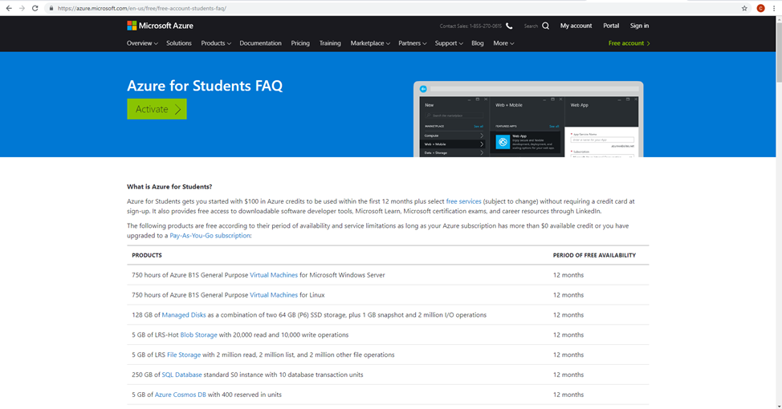

Azure - Figure

1. Use an existing Microsoft account or create a new one using a personal email (aggiemail will not work for this step).

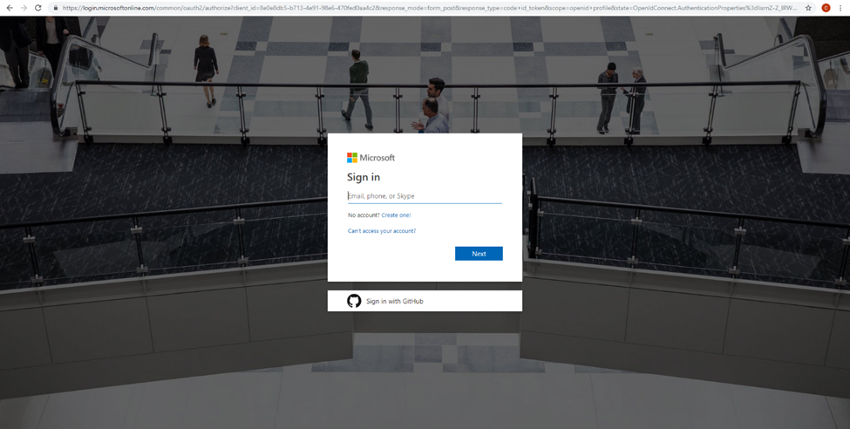

Azure - Figure

1. Select ‘school email address’ as the verification method and enter you aggiemail email address to verify your academic information.

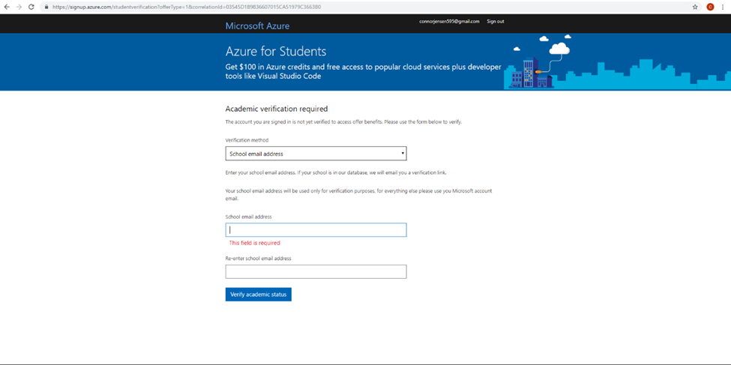

Azure - Figure

1. Go to aggiemail account and click the link to verify your academic information. You will be returned to the azure website.

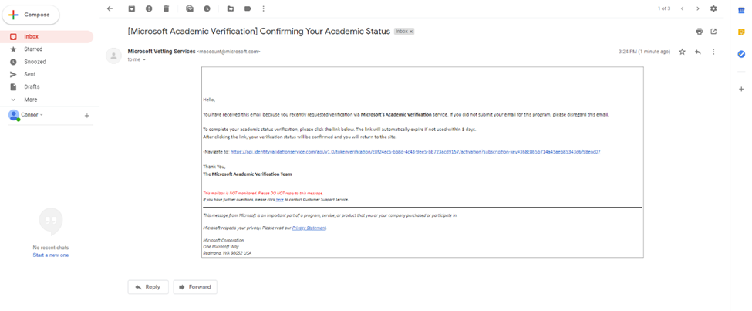

Azure - Figure

1. Fill out the require information and enter the verification number sent to your phone.

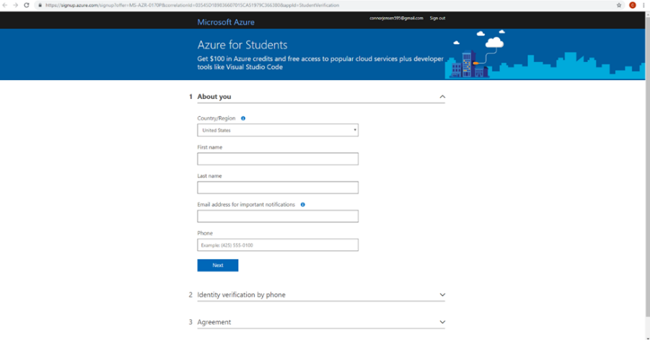

Azure - Figure

1. Click “I agree” and click “create account”.
2. After you create account and activate “Azure for Student”, it will take you to the portal of Azure.

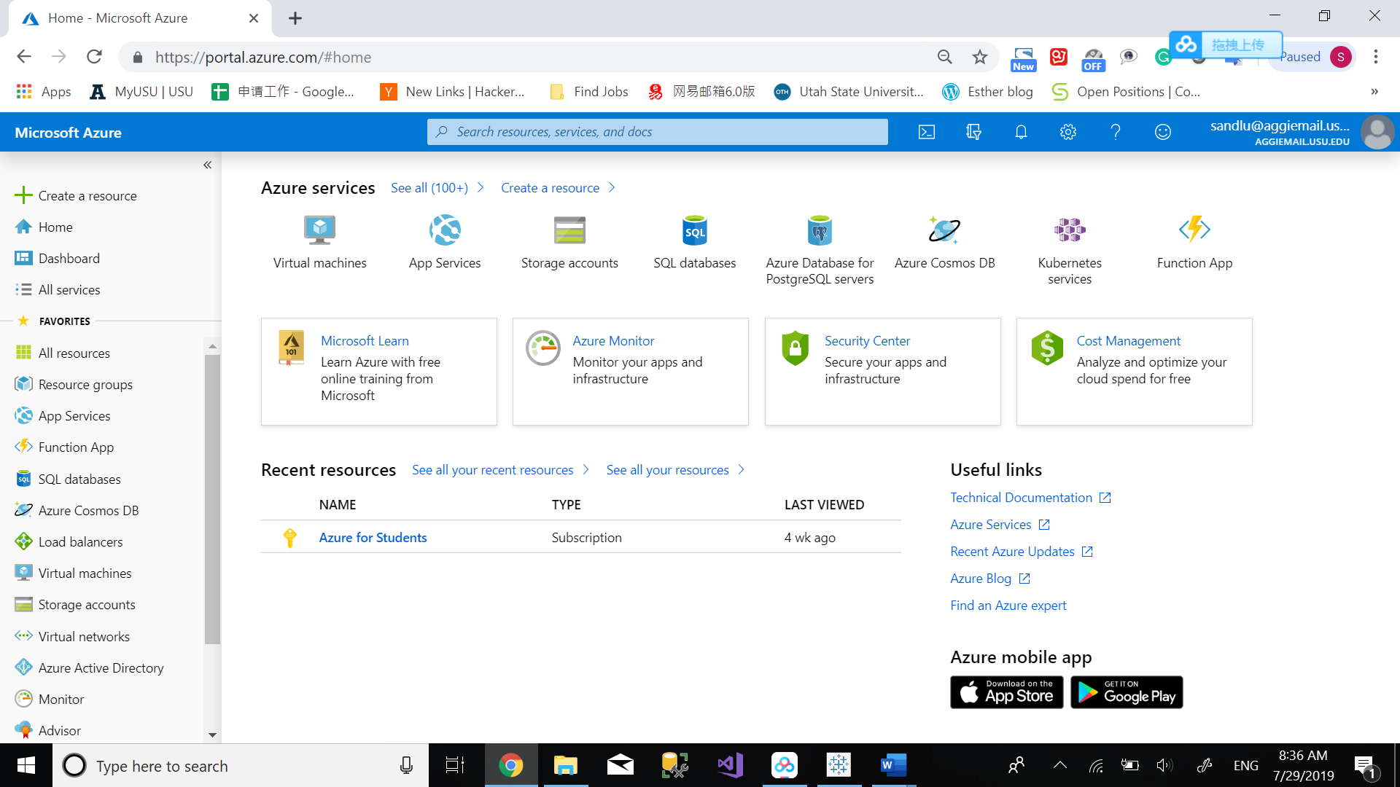

Azure - Figure

1. If not, go to <https://azure.microsoft.com/en-us/account/>, click “ Go to the portal”.

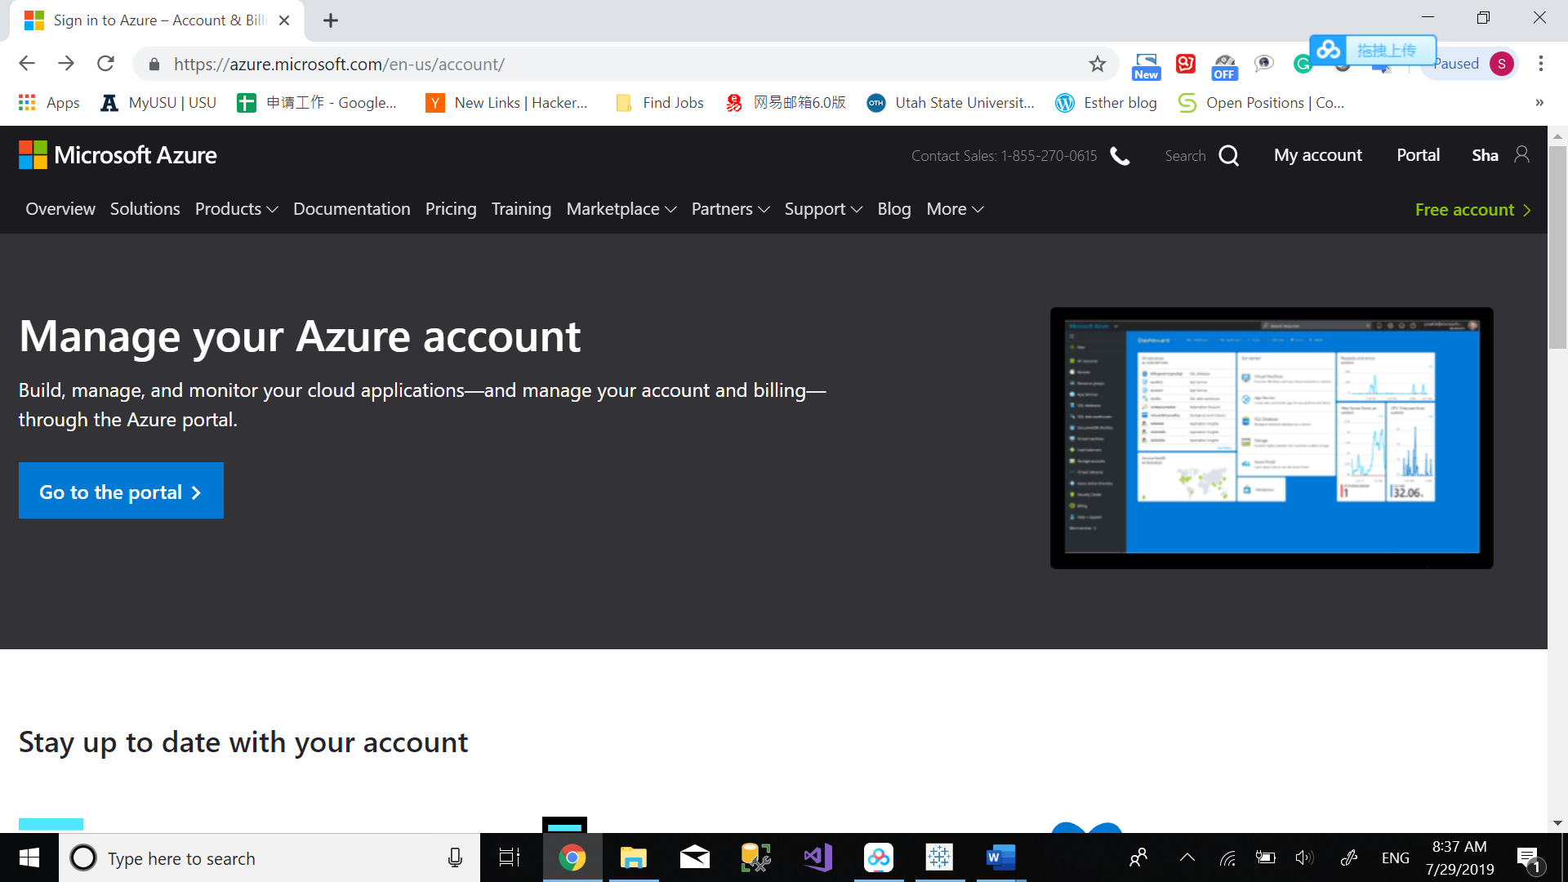

Azure - Figure

# Step 2: Set up a SQL Server and SQL Server Database

Click “Create a resource” on the left side of Portal of Microsoft Azure.

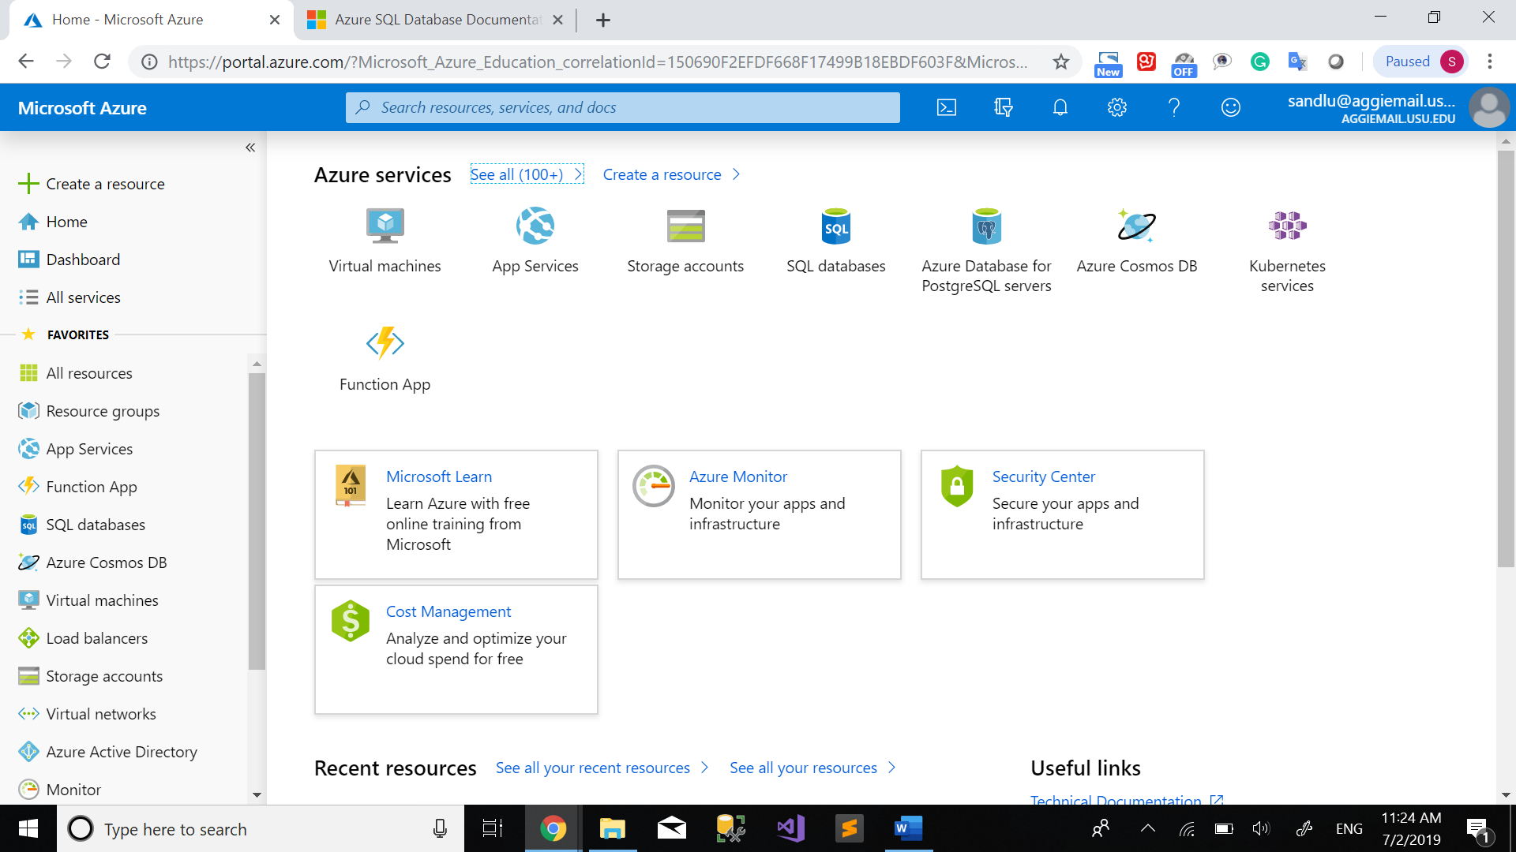

Azure - Figure 8

Click “Databases” under Azure Marketplace and navigate to “SQL Database”. Click “SQL Database”.

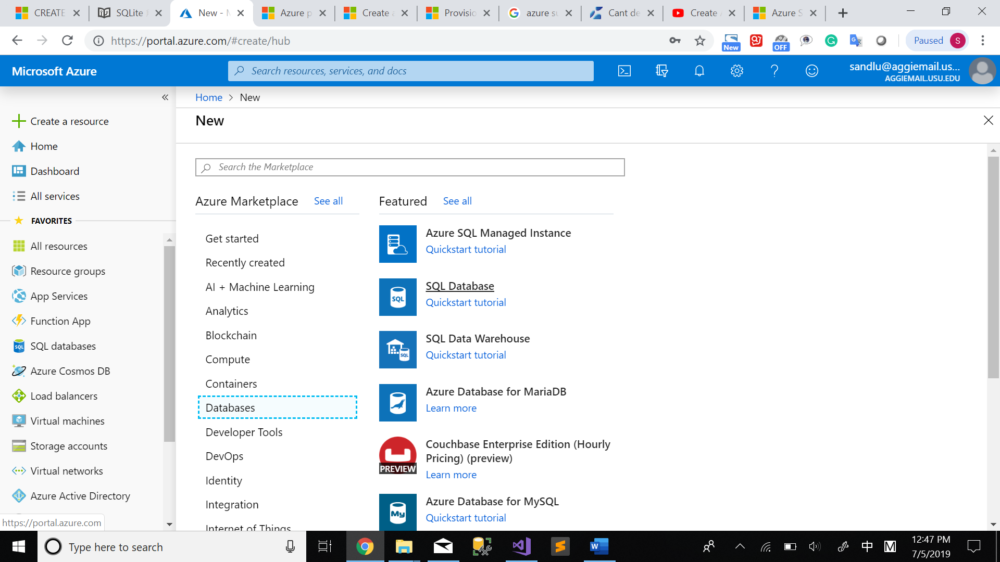

Azure - Figure 9

Then the “Create SQL Database” page pops up.

PROJECT DETAILS

Subscription: “Azure for Students”. You don’t need to select; it shows up automatically by itself.

Resource group: click “Create New”, then define the name you want for it.

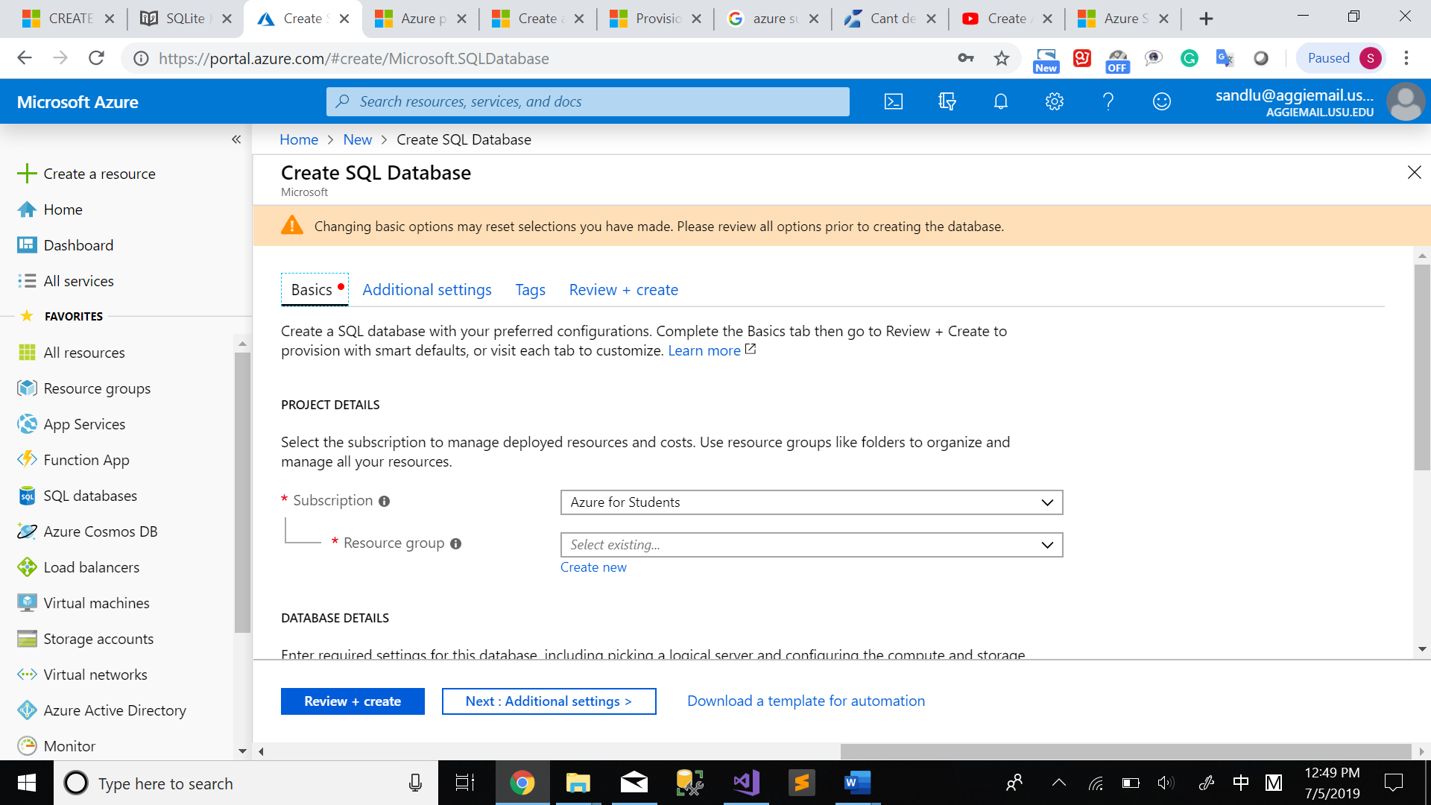

Azure - Figure 10

Define the name for your resource group. Then click “OK”.

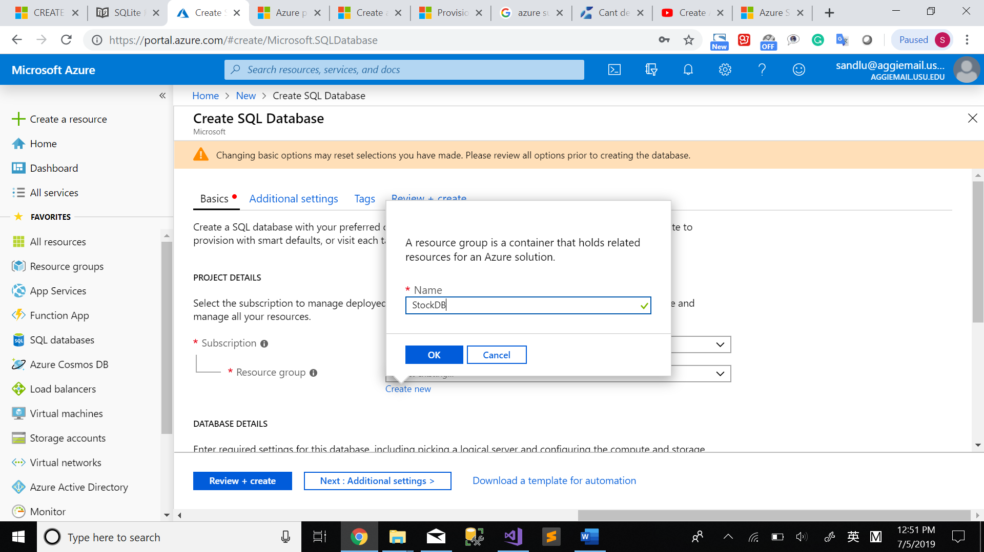

Azure - Figure 11

DATABASE DETAILS

Database name: Define the database name you want, mine is “StockDB”

Server: Click “Create new”

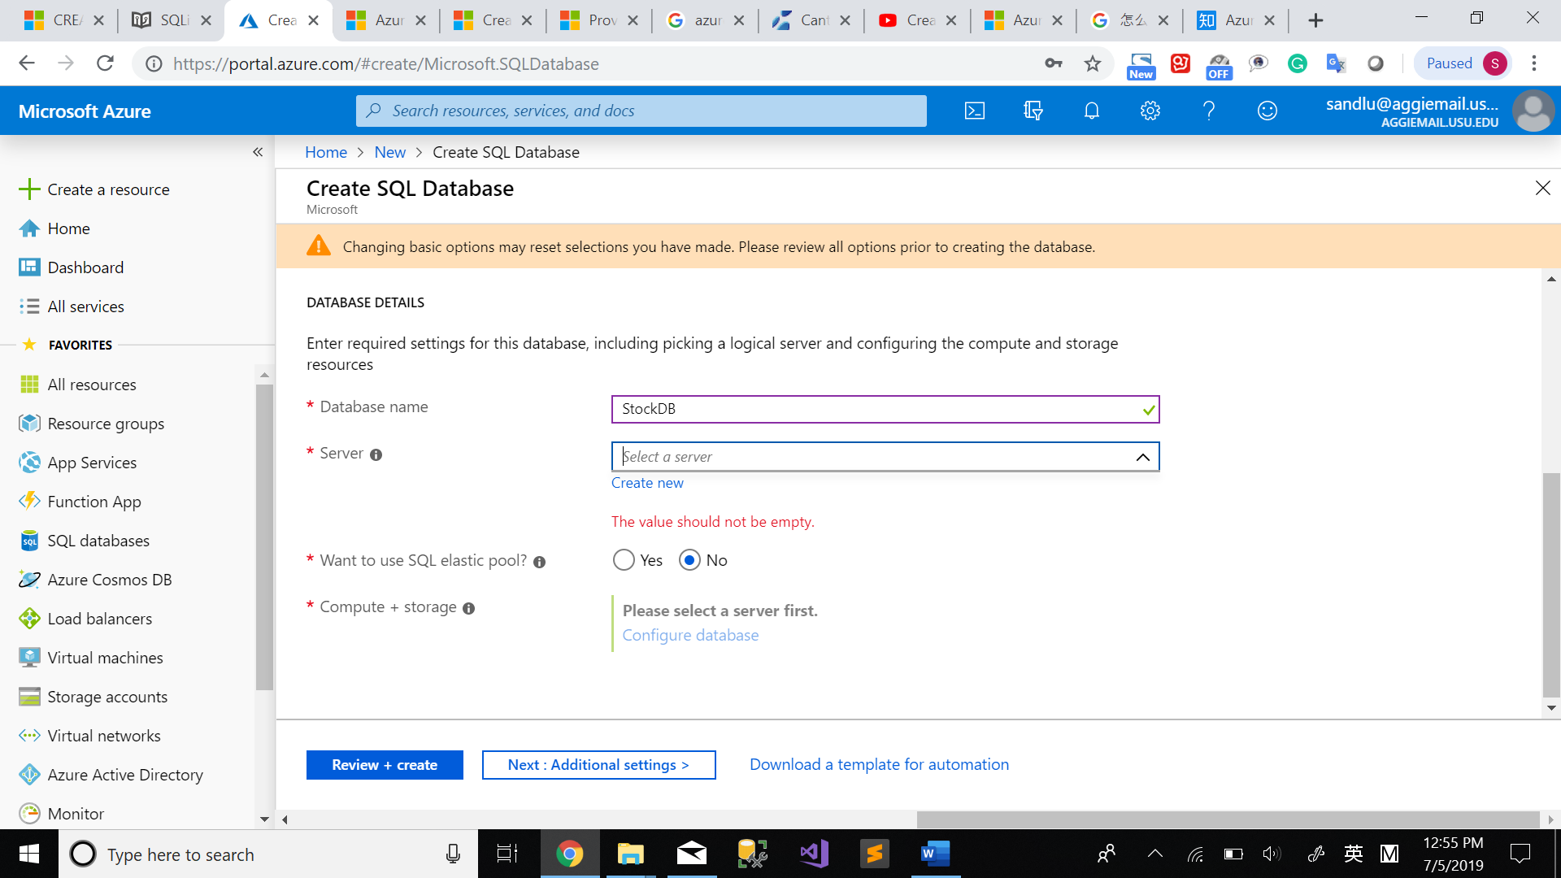

Azure - Figure 12

The new server set up page pops up on your right side of the windows.

Type the information to create your own server. If you want to query your database using Azure in future, remember to check “Allow Azure services to access server”. The below screenshot is an example. Then create “OK”.

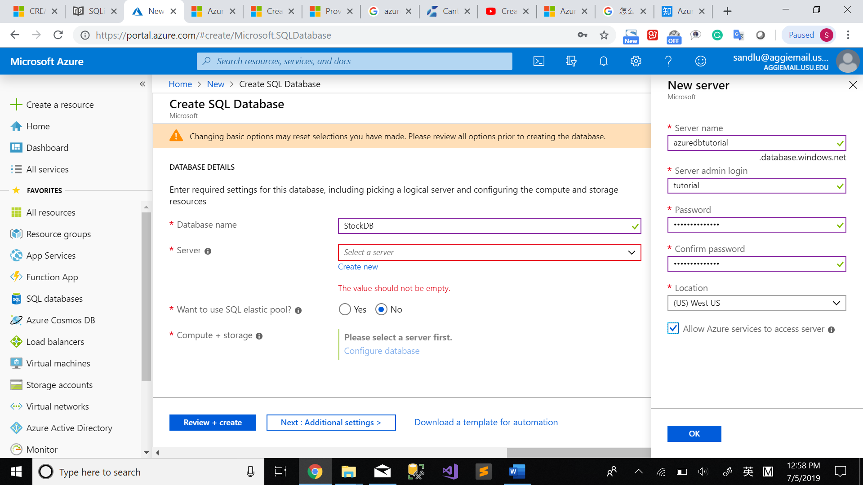

Azure - Figure 13

“Computer + storage”: Click “Configure database” which shows you different storage size of your database. Click “Standard” in the page, then you can see the windows as below. The Azure free account has the free access to some products for the first 12 months, and 250 GB of SQL Database standard S0 instance with 10 database transaction units is one of them. If you just want to explore Azure database, remember to choose 10(S0). Click “Apply”.

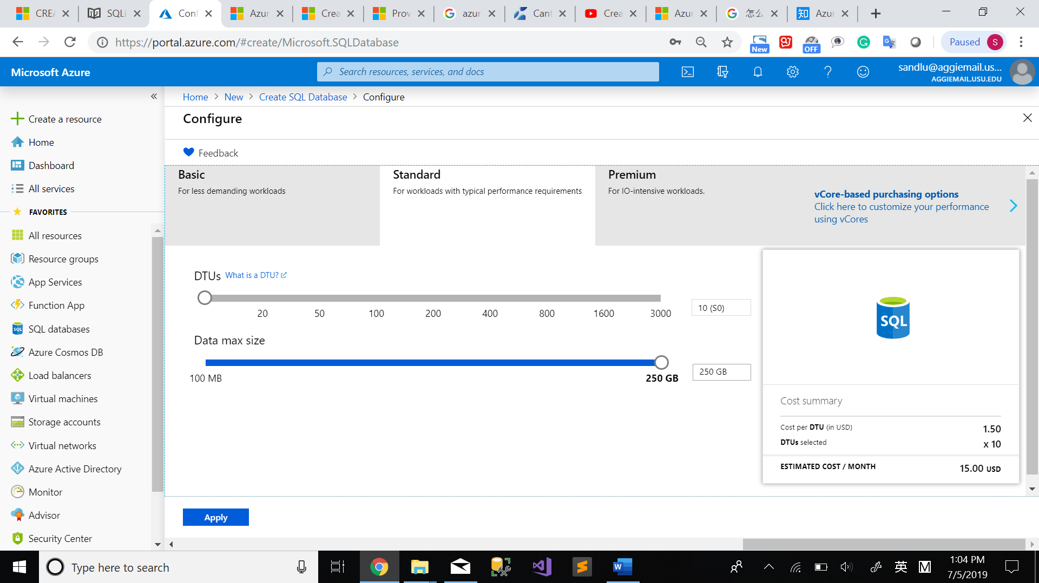

Azure - Figure 14

Click “Preview + Create”, then you can see the price for the database. Click “Create” if the design is correct. It might take several minutes, but you can use the “Notifications” in the left side to check the progress.

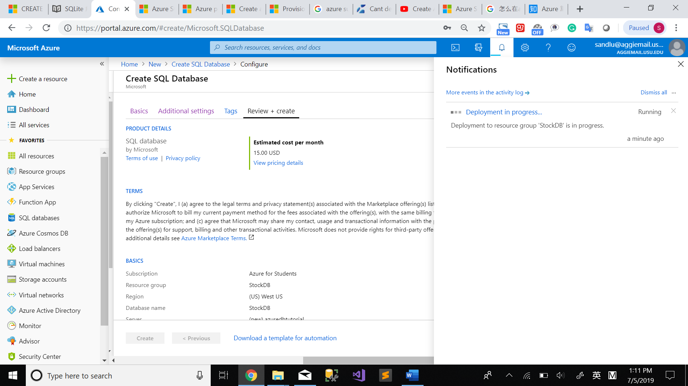

Azure - Figure 15

When the deployment is finished, it will show on the notification. Click “Go to resource”.

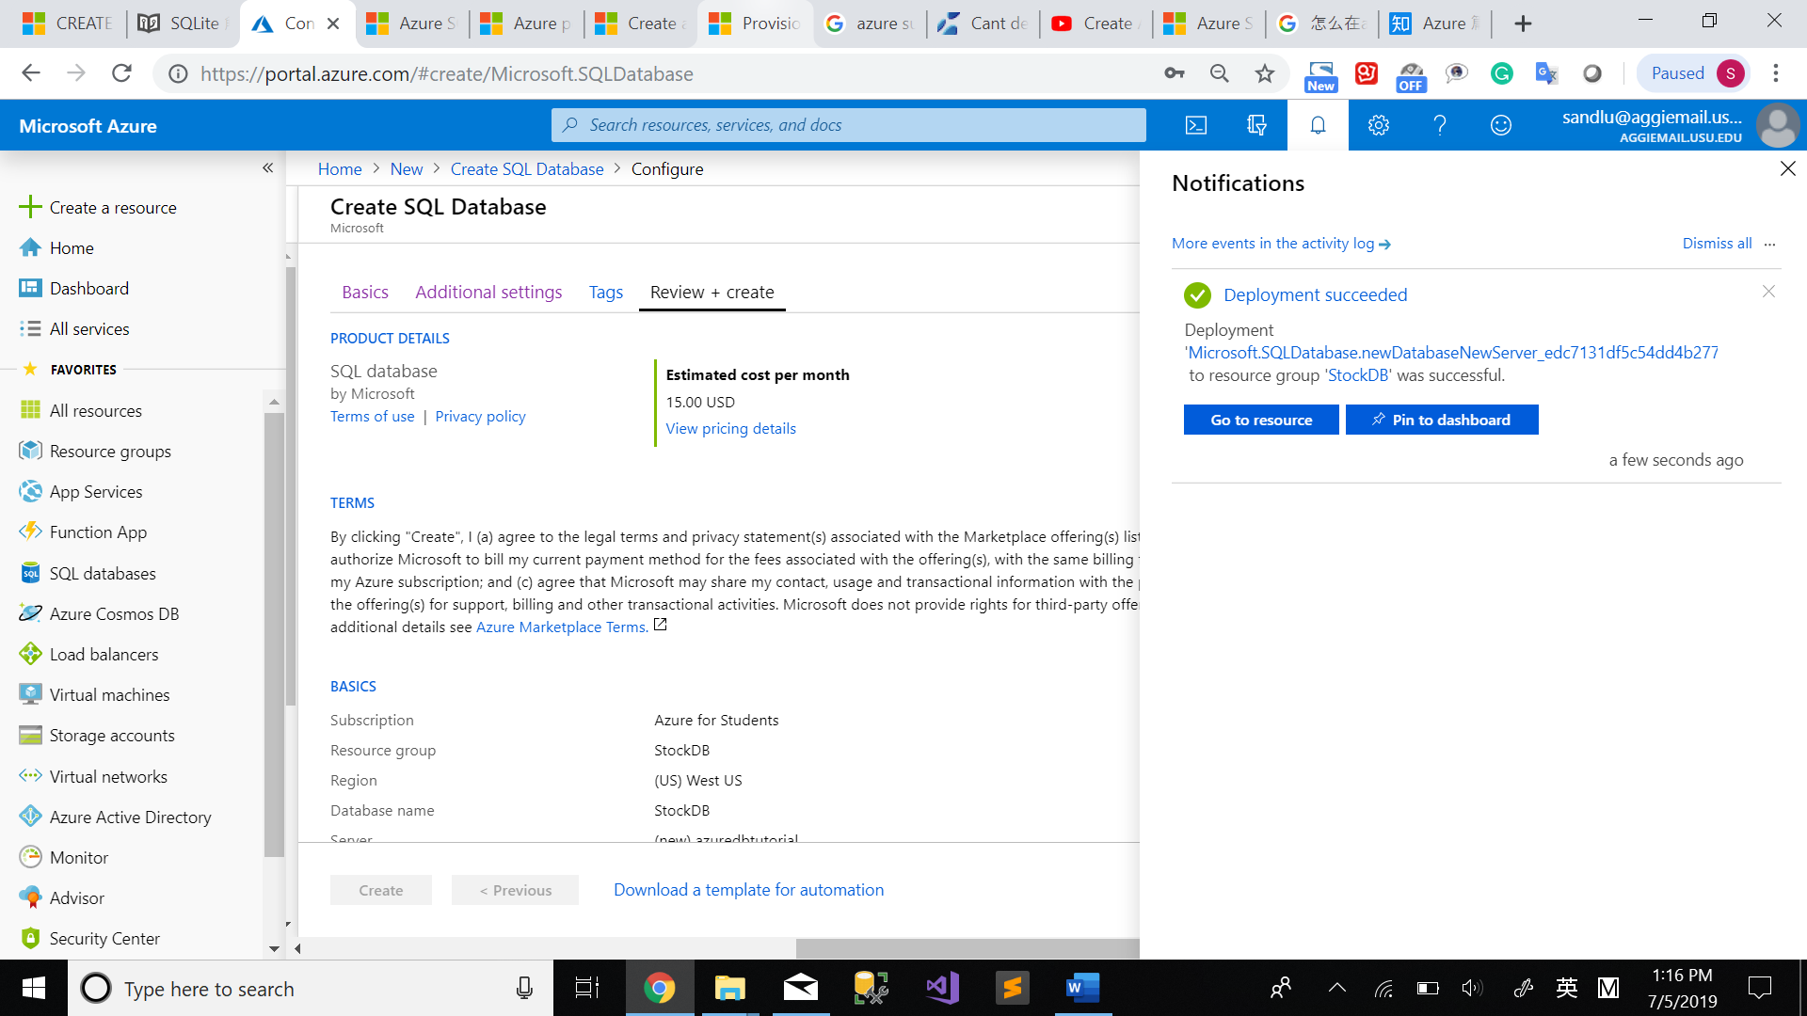

Azure - Figure 16

Copy the Server name on the right side of the page. Then you can open SSMS and log in with the login name and password you created for the SQL Server.

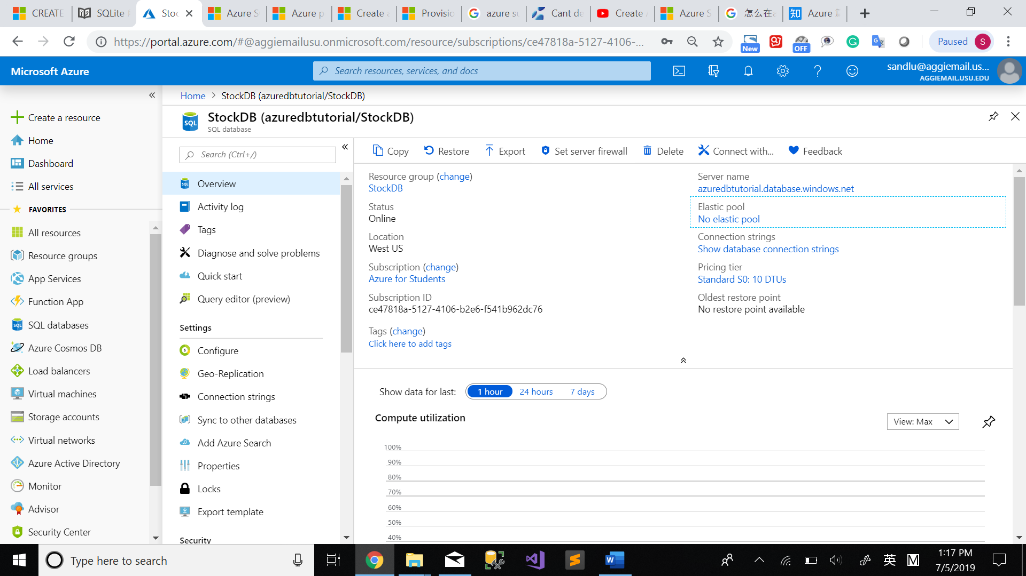

Azure - Figure 17

Open the SSMS, the “Connect to Server” windows pop up, enter the right information you just created. Click “Connect”.

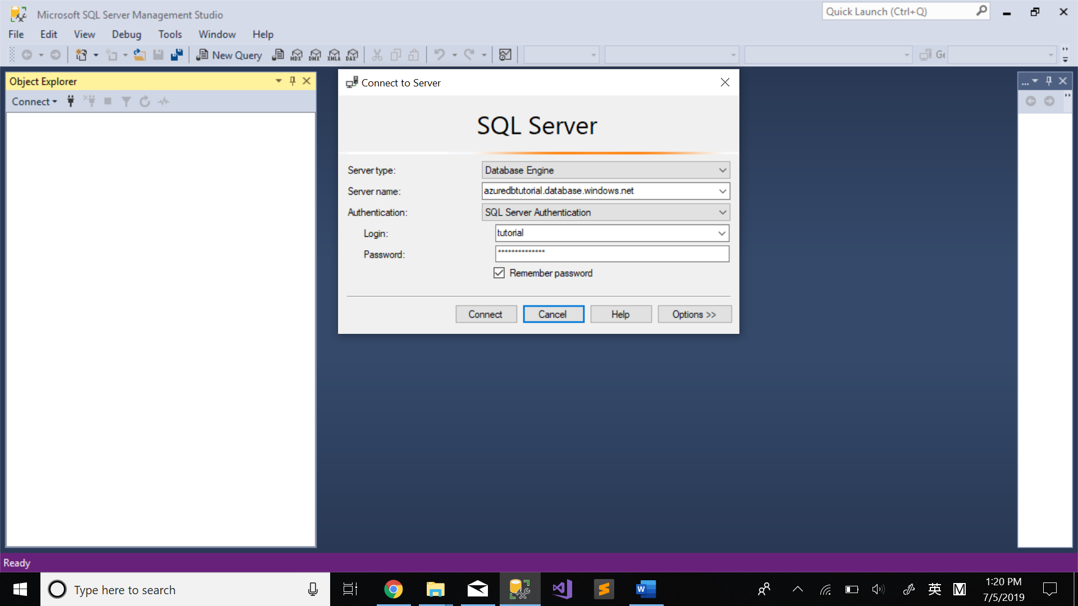

Azure - Figure 18

You can log in with your Azure account to add the ip address to your Azure sql server. If you want to know more about the firewall rules, you can refer to the firewall rule tutorial later.

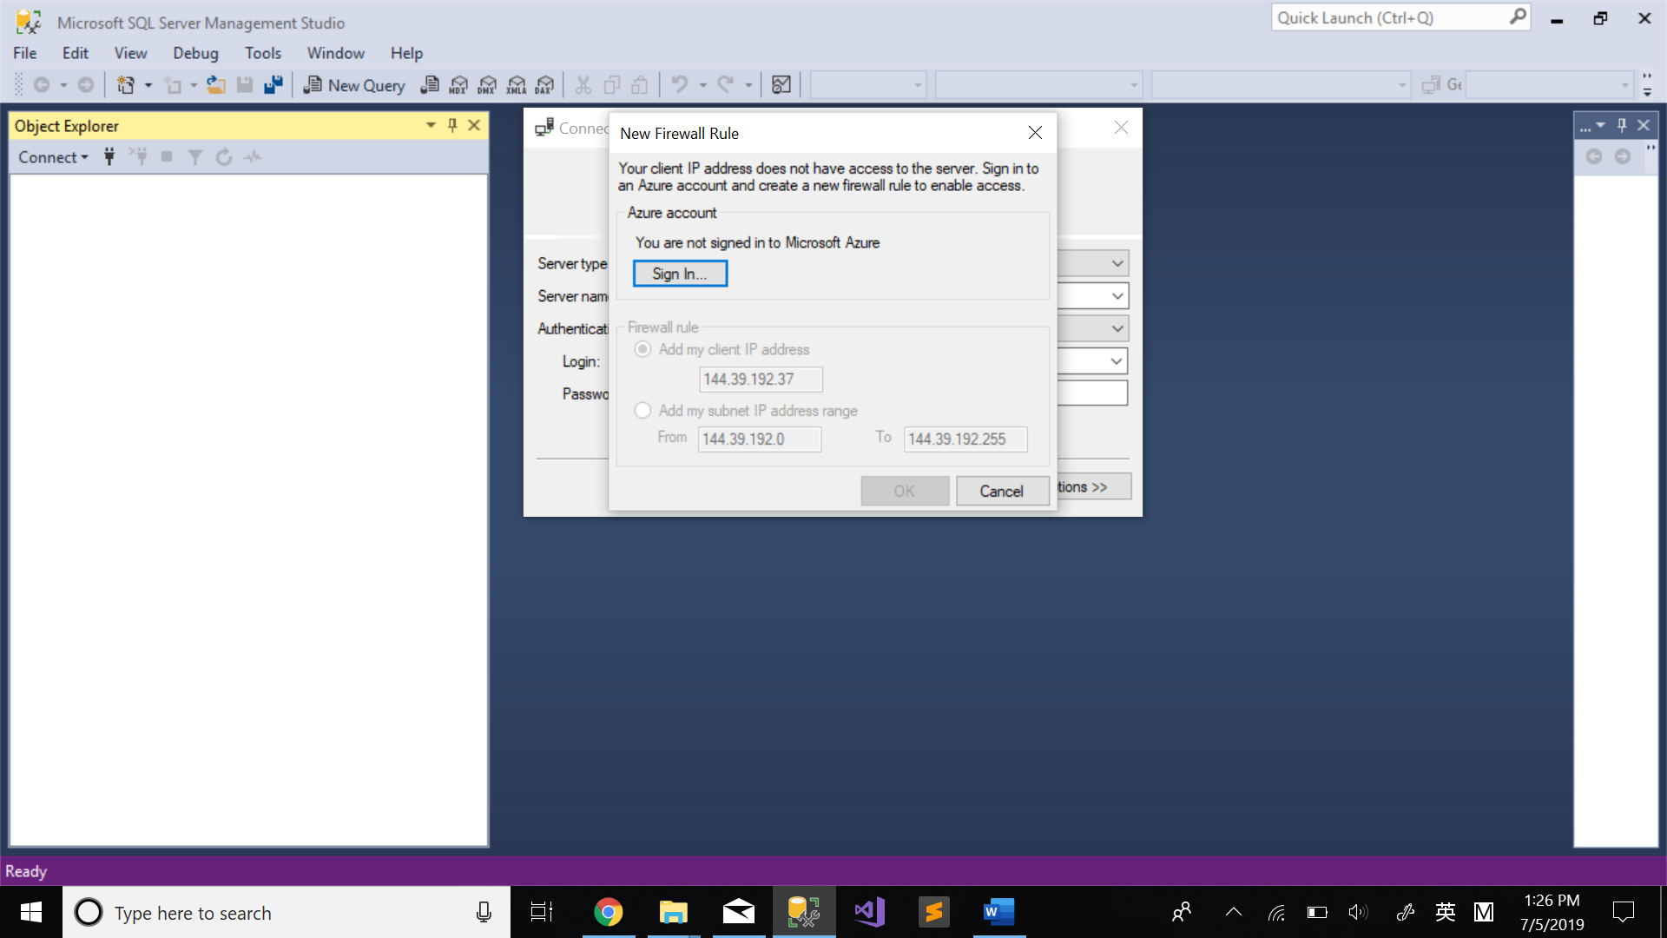

Azure - Figure 19

After logged in, then you can see the database you just created.

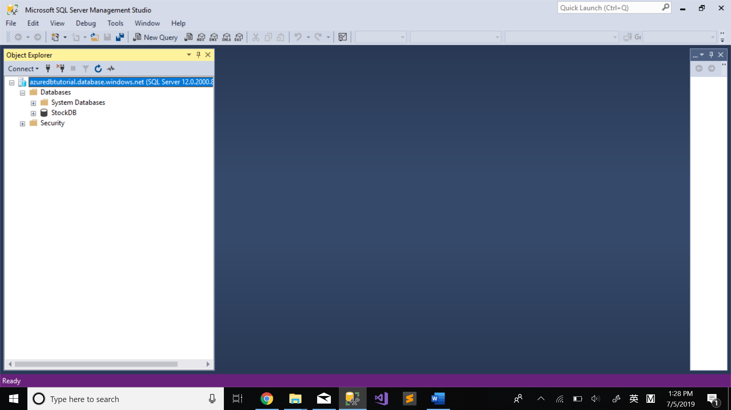

Azure - Figure 20

You can see the database you just create, or you can create a new database here. But when you create a database by SSMS, Azure chooses the size of the database for you which will have some unexpected cost. I would suggest creating new database in the Azure portal.

You can also use Azure to query your database.

Click “SQL databases” on your left side on the Azure dashboard, click the database you just created.

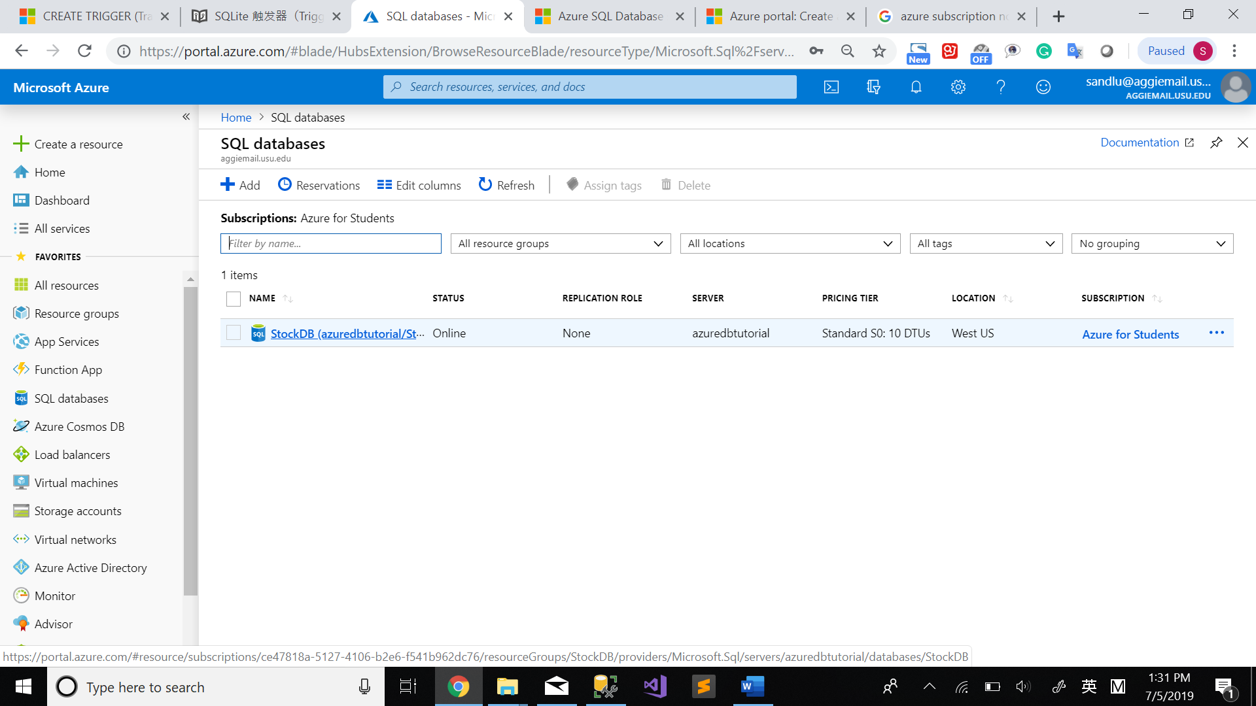

Azure - Figure 21

Click “Query editor” on the next page. Log in with your database name and password.

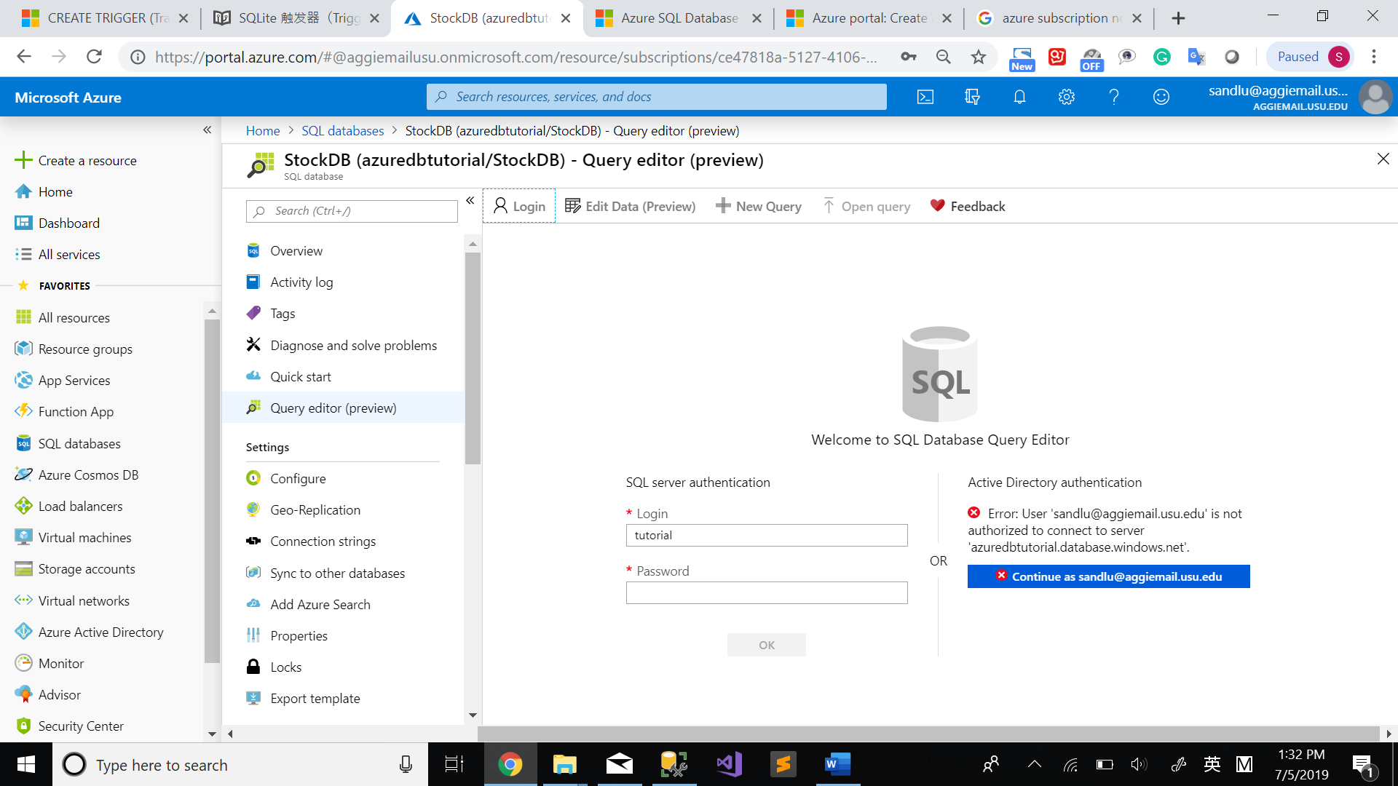

Azure - Figure 22

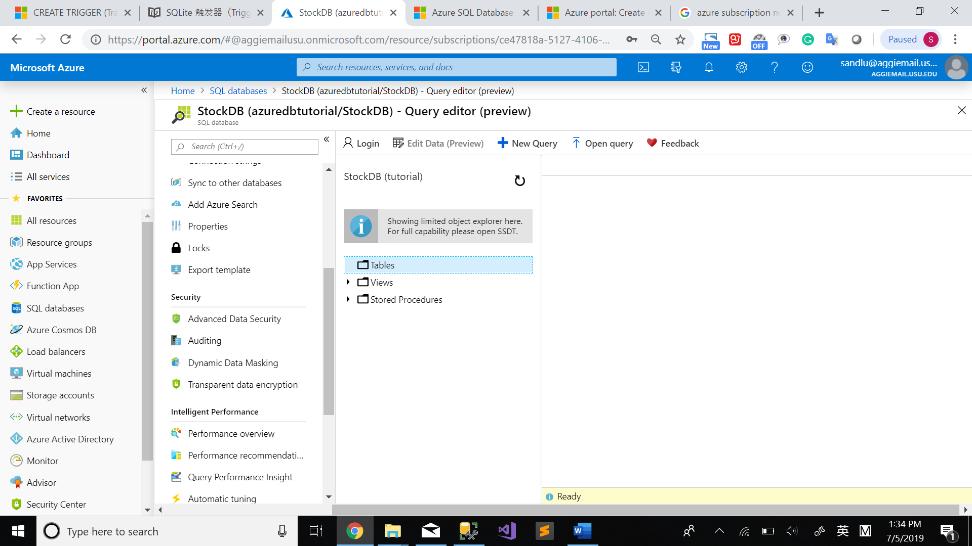

Azure - Figure 23

# Step 3 Clean up the resource.

When you don’t need the resource anymore, you can delete them from future charges.

Select “Resource groups” on the left menu in the Azure portal, and then select StockDB.

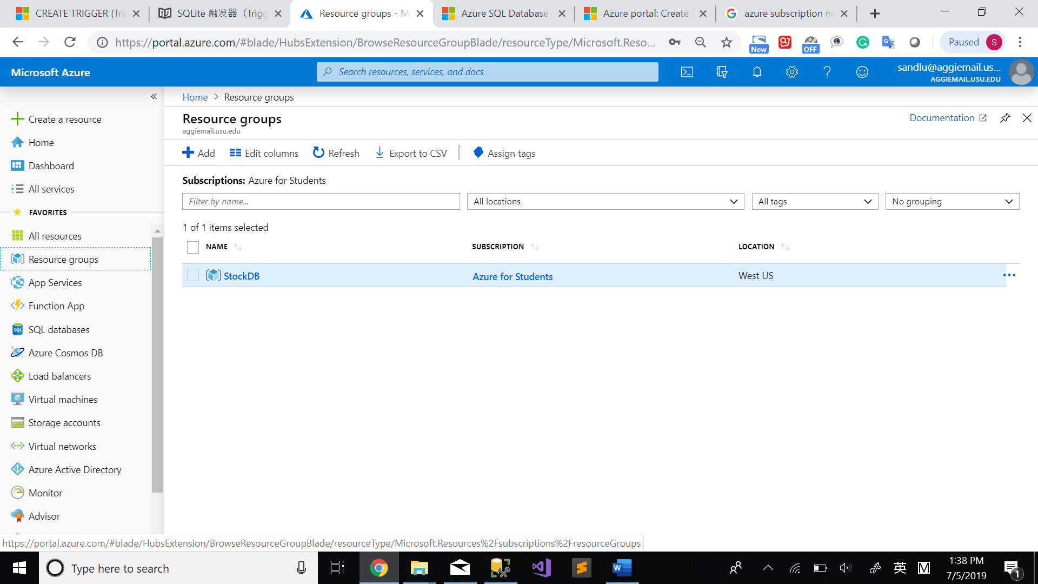

Azure - Figure 25

Select “Delete resource group” from the context menu as shown in the below screenshot.

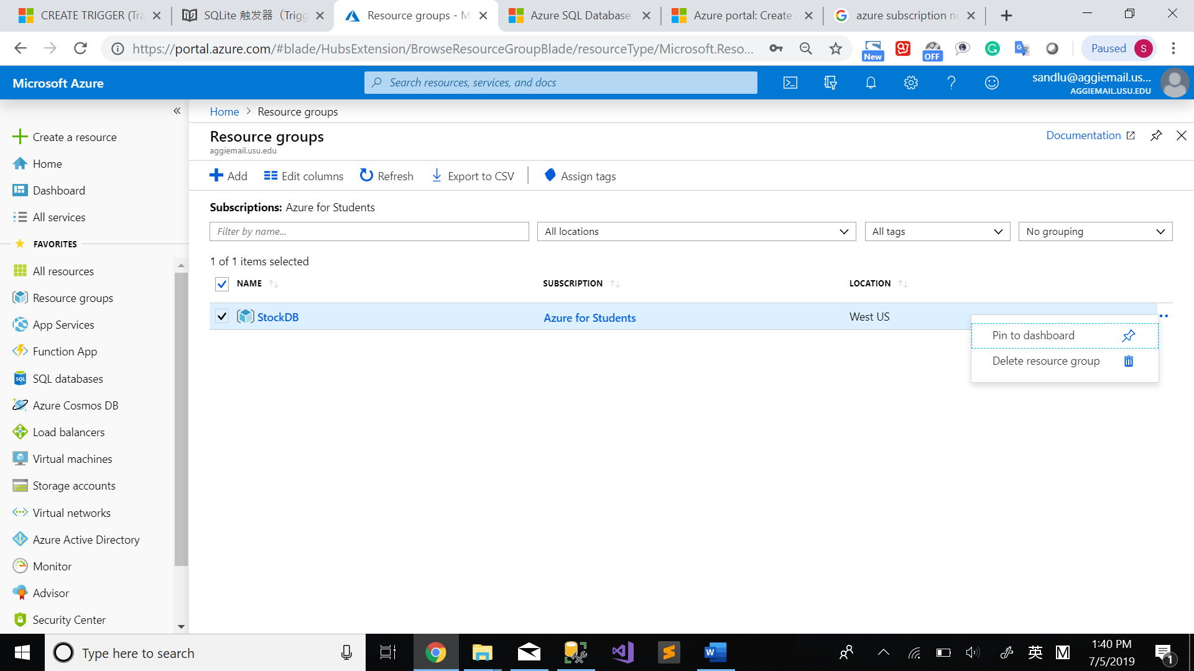

Azure - Figure 26

Enter stockdb in the field, and then select Delete.

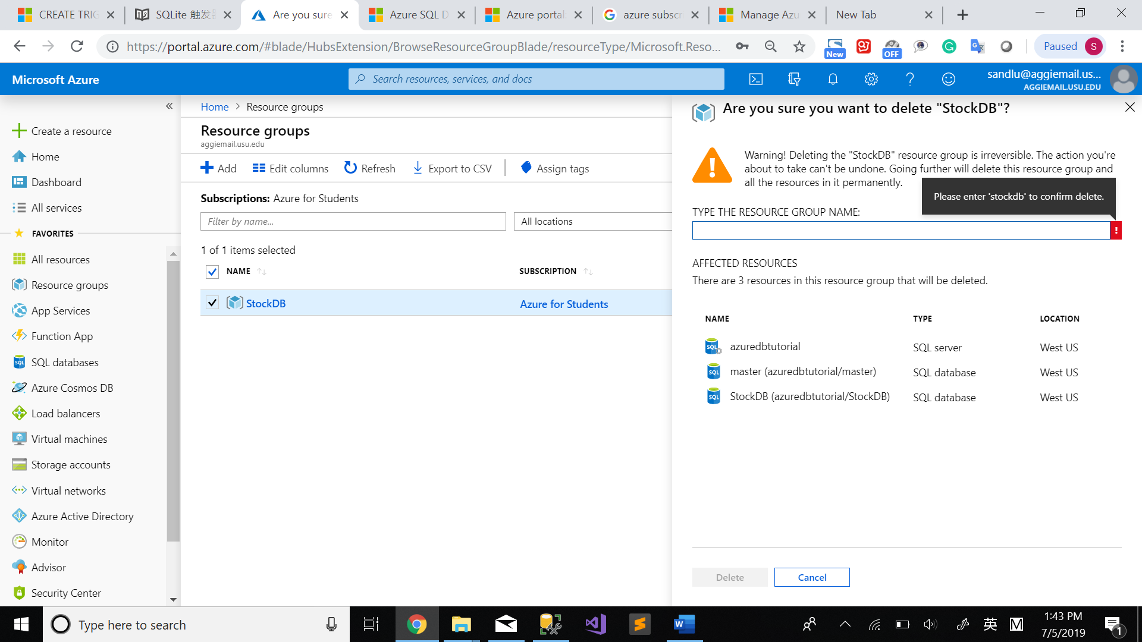

Azure - Figure 27

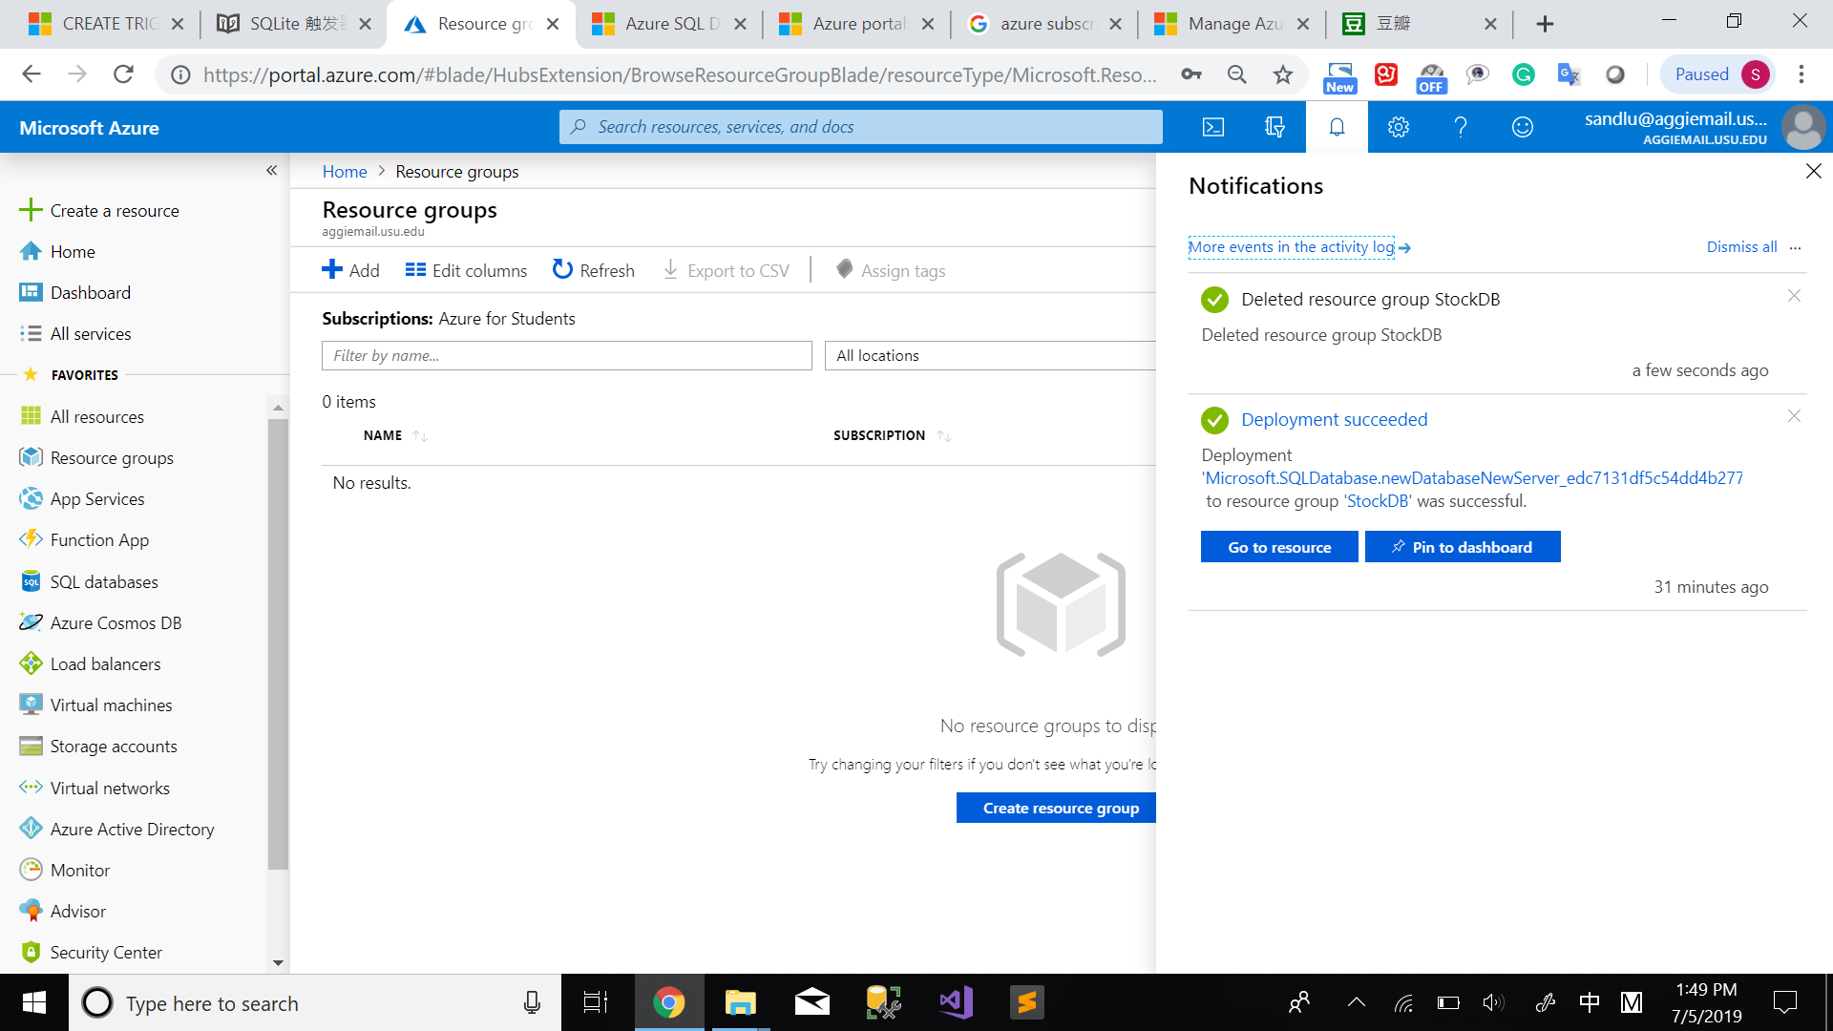

Azure - Figure 28

# Reference

[Tutorial: Design a relational database in a single database within Azure SQL Database using SSMS](https://docs.microsoft.com/en-us/azure/sql-database/sql-database-design-first-database)

[Azure free account FAQ](https://azure.microsoft.com/en-us/free/free-account-faq/)

[Elastic Pool](https://docs.microsoft.com/en-us/azure/sql-database/sql-database-elastic-pool)